UNA VENTANA AL UNIVERSO

2025-2026

-

E5: Introduction to orbits and black holes

-

Worksheet 2: Plotting Einstein’s orbits with Python

David Sola Gil
(AAEC)

Introduction

In 1915, Albert Einstein revolutionized our understanding of the cosmos with General Relativity. This theory invites us to understand gravity not merely as a force, but as a manifestation of the curvature of spacetime caused by the presence of mass and energy.

In this second worksheet, you will delve into how the Schwarzschild metric—one of the simplest solutions to Einstein's equations—introduces subtle yet fascinating corrections to Newtonian mechanics. Your goal will be to use the computational power of Python to tackle problems of greater mathematical complexity. This is where programming becomes an indispensable pedagogical tool, allowing you and your students to visualize phenomena beyond algebraic abstractions.

Note: To get the most out of this session, it is recommended that you have previously completed Worksheet 1, where the foundations of the Python syntax and how to use Google Colab are established.

Einstein’s effective potential
The Schwarzschild solution describes gravity around a body with mass $M$, chargeless, As observed in the theoretical framework, the effects of the Schwarzschild solution on the orbit of a body of mass $m$, located at a distance $r>2GM/c^{2}$ can be captured by adding an additional term to Newton's effective potential, such that
$$V_{eff}\left(r\right)=-\frac{mk}{r}+ \frac{ml^{2}}{2r^{2}}-\frac{mkl^{2}}{c^{2}r^{3}}$$
Here $l$ is the angular momentum per unit mass, and $k=GM$, with $G=6.674×{10}^{-11} N⋅\frac{m^{2}}{kg^{2}}$. Use Python to graphically represent this new effective potential. It is fundamental that you invite students to compare both curves (Newton vs Einstein).

- What happens to the function as $r→0$? And for $r→∞$?
- Are there local extrema? For what values of the constants? Where and of what type?
- Look for the relevant constants for the Earth orbiting the Sun. What orbit are we in?

Again, it is crucial to compare the orbit obtained according to the initial distance and the energy $E$ of the system. What crucial difference do you observe with respect to Newtonian orbits? Make a graph comparing both potentials.

For the graph below, I used the constants $l=4k/c$, $m=100$, $k= 1, c=1$I encourage you to play with the parameters l and m to see how the graph evolves.
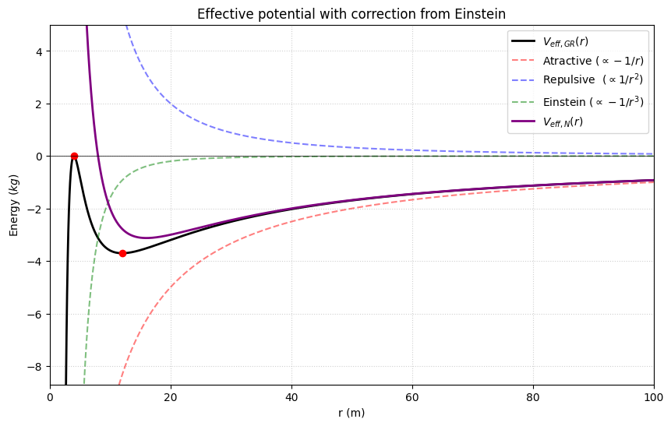

3. Plotting gravitational orbits
By introducing relativistic corrections, we encounter differential equations that lack a simple analytical solution. However, this is the ideal scenario to demonstrate the value of numerical calculation. We will use an approximation for the trajectory $u\left(ϕ\right)$ where the constant $β$ represents that small deviation that Einstein managed to explain. As we saw in the notes, we have
$$u\left(ϕ\right)=u_{0}\left(ϕ\right)+β u_{1}(ϕ),$$
where $β=3k^{2}/l^{2}c^{2}$ is a small constant. The functions $u_{0}\left(ϕ\right)$ and $u_{1}\left(ϕ\right)$ are given by
$$u_{0}=\frac{k}{l^{2}}(1+e\cos\left(ϕ\right)), u_{1}(ϕ)=\frac{k}{l^{2}}\left(\left(1+\frac{e^{2}}{2}\right)+e ϕ\sin\left(ϕ\right)-\frac{e^{2}}{6}\cos{(2ϕ)}\right) .$$
Here $e$ is our old friend: the eccentricity. Using this correction to the orbit (note that it is $u$ and not $r$), follow the next steps.
- Draw the orbit of Mercury using both the Newton and Einstein estimates. Is there any significant difference? What do you think this is due to?
- Compare the estimated orbit of Mercury with that of JPL Horizons.
- Try ignoring the actual value of $β$ and use $β=4/100$. What happens to Mercury's orbit now?

